Signing up to meet-thy-maker

Click on the “Artist/maker link”

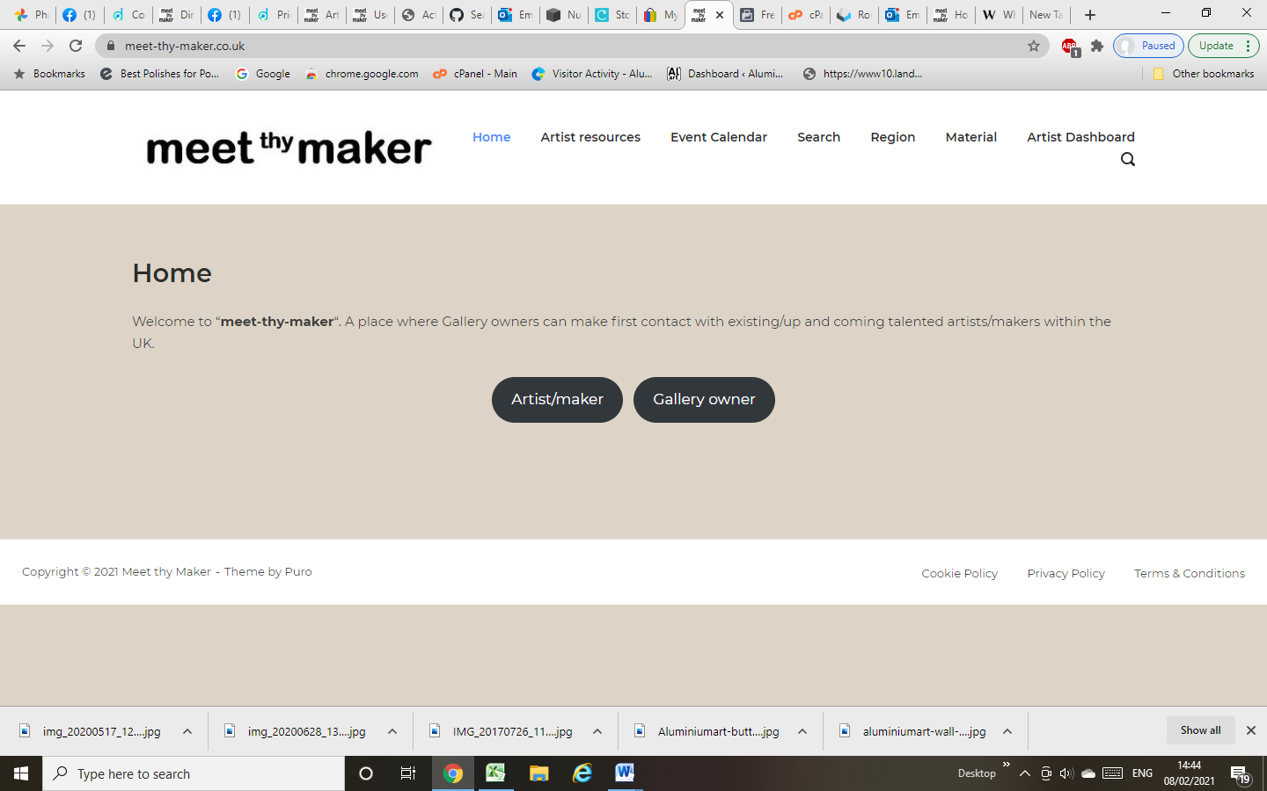

Read the information as it is important!

Click on the “Artist/maker sign up”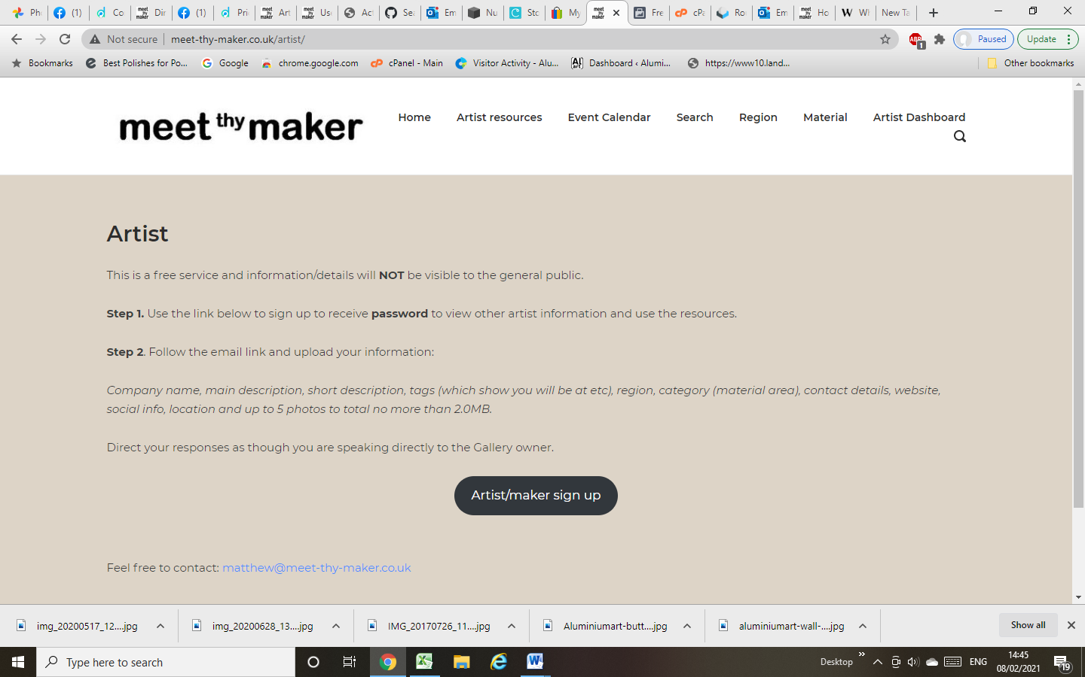

Enter your details to sign up.

Step 1 This is just a sign up process which allows you to get access to the resources and see other artist info. Fill it in and receive an email

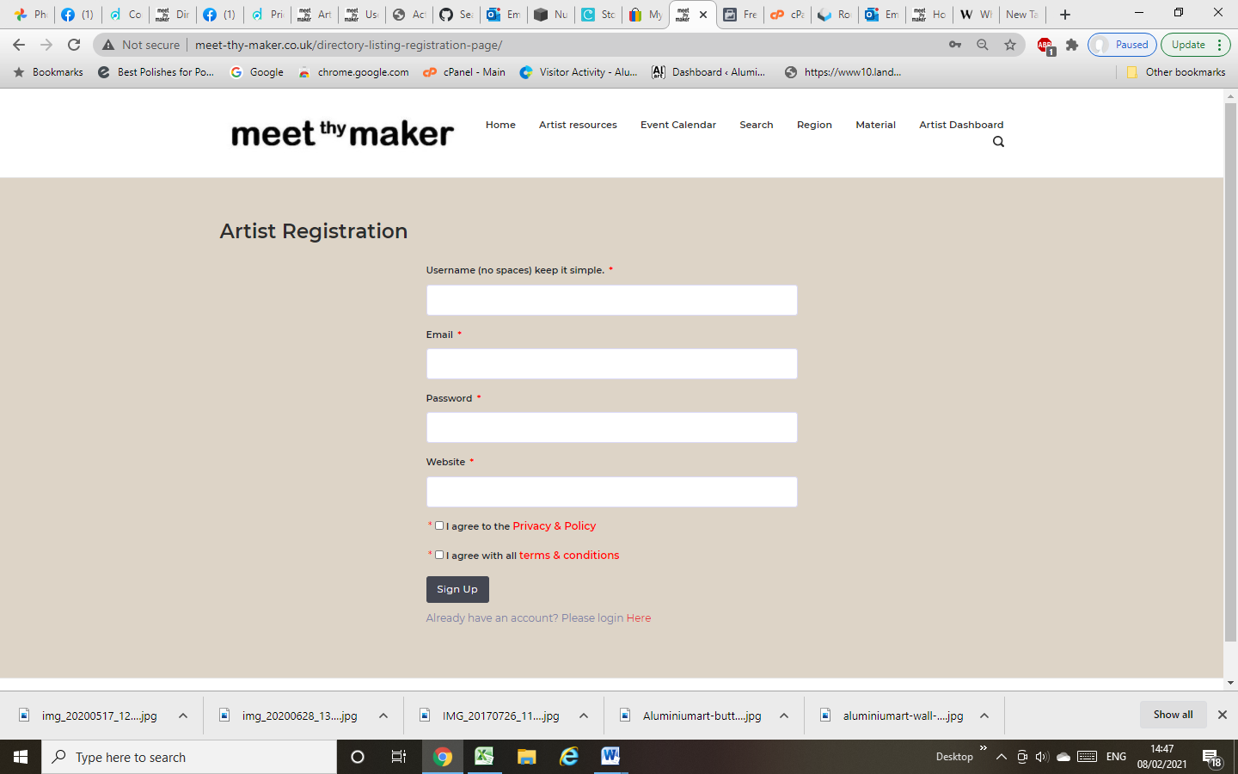

Receive the email from [matthew@meet-thy-maker.co.uk](mailto:matthew@meet-thy-maker.co.uk)

*Note check your spam folder*

Step 2. Follow the instructions in the email

Select the link in the email to upload your company details.

Thank you, Matthew, for signing up with Meet thy maker.

You may complete your registration with additional information or update your information by visiting this private link at any time: <http://www.meet-thy-maker.co.uk/meet-thy-maker-further-detail/?pid=2O61Y>.

**NOTE**. Artist information is password protected. To view your details and look at the artists information pages please use **password: \*\*\*\*\*\*\*\*\*\***

**Add all YOUR DETAILS to the page (below)**

**Please follow the notes/details and complete the essential items.**

**Upload 5 photos which all add up to 2.0MB in total.**

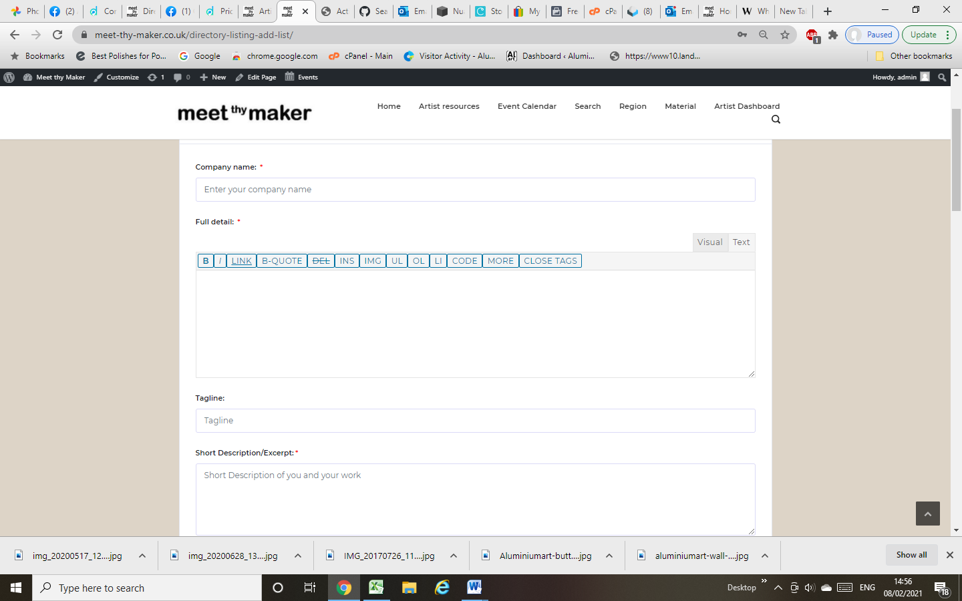

Once submitted you will need to wait for approval. (I will approve as soon as possible)

Any questions, re-read these instructions first, then enquire at my email address (above)