From the Artist Dashboard you can login to get to this screen. Here you have two options to edit your listing.

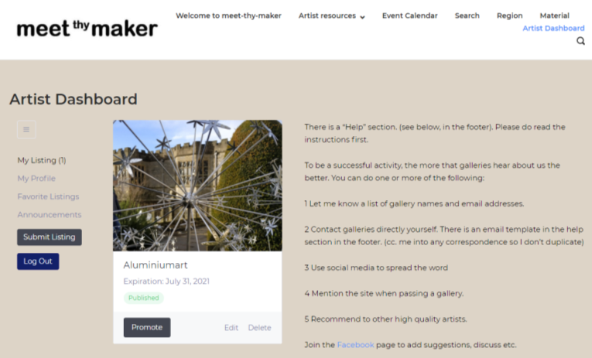

Two areas to edit your information.

1 My profile

2 Edit listing

The “My Profile” section gives details “About” the author.

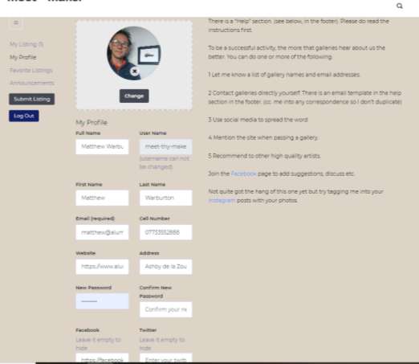 Here you can edit or add various information, About the author is listed at the bottom which gives you an opportunity to write about yourself. You can also add social media links, change login details etc.

Don’t forget to “SAVE” your work which is located at the bottom of the page.