Changing your listing

Go to Artist Dashboard from the top menu

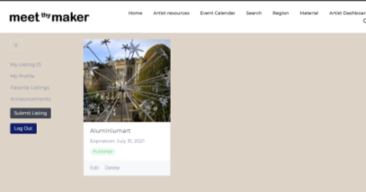

Make the necessary changes to your listing.

To add photos scroll down toward the bottom of the page then add up to 5 images. Total not to exceed 2.0Mb

Have your filenames: meet-thy-maker [artist name] [name of piece]

(This allows search engines find images easier)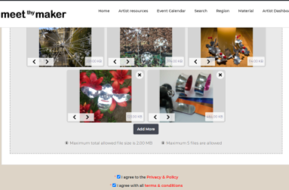

Scroll down to the bottom of the page, add your gallery contact details then select “Preview”.

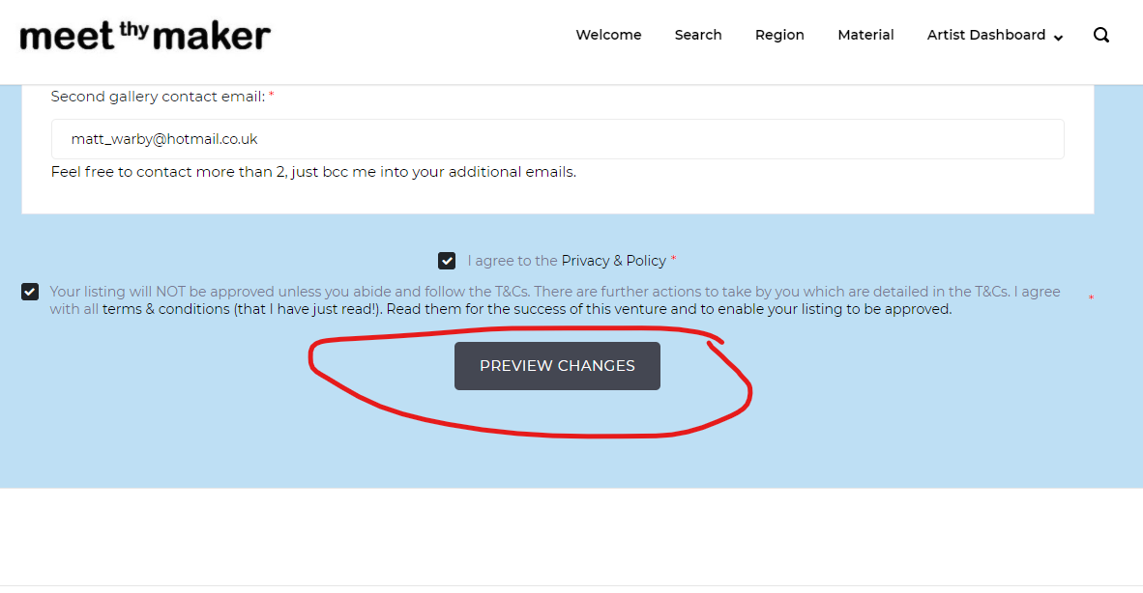 Click “Continue” to submit your listing for approval.